**How to use MSwM2 package**

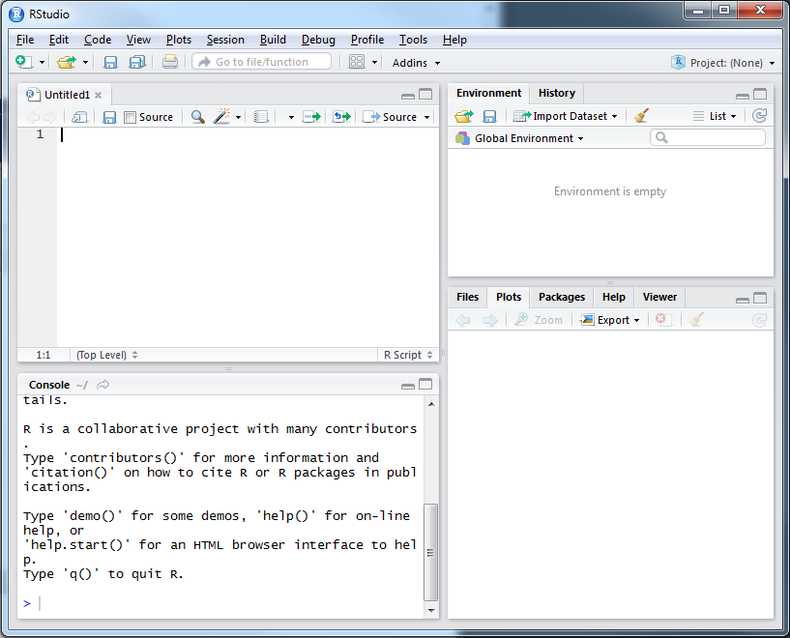

Go to “Project: (None)” 🡪 “Open Project…” 🡪 Then, find the R project of MSwM2 and open it.

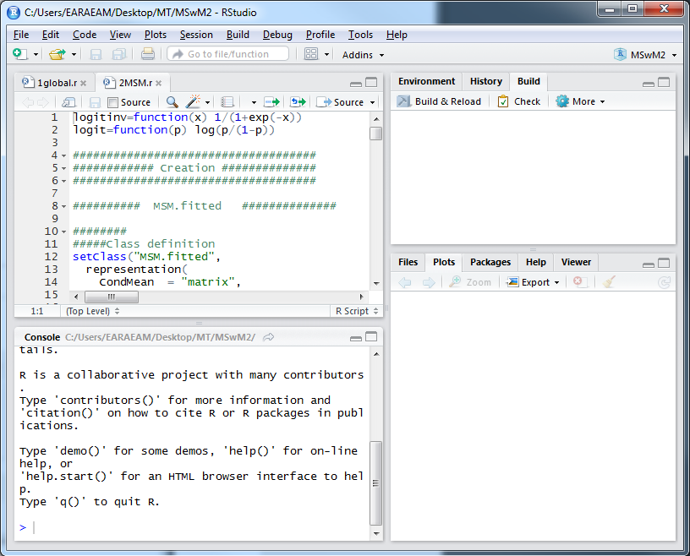

Select “Build” 🡪 Click “Build & Reload”

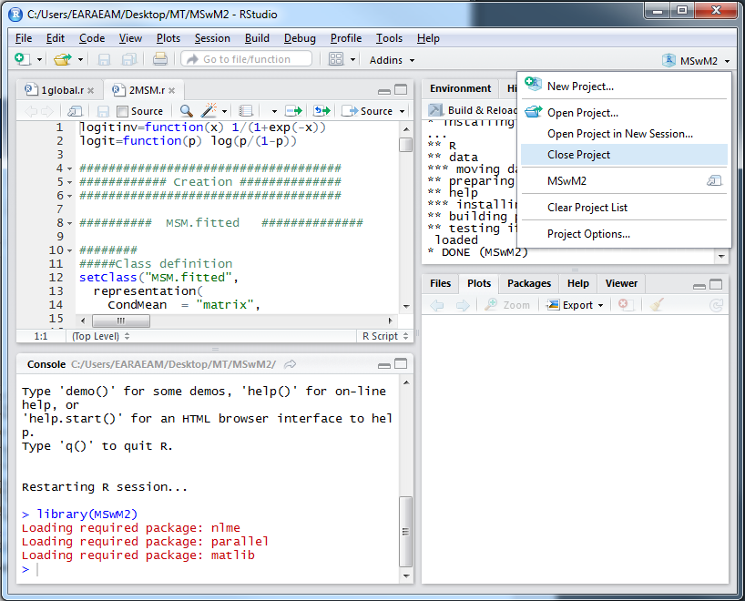

Go to “MSwM2” 🡪 “Close Project”

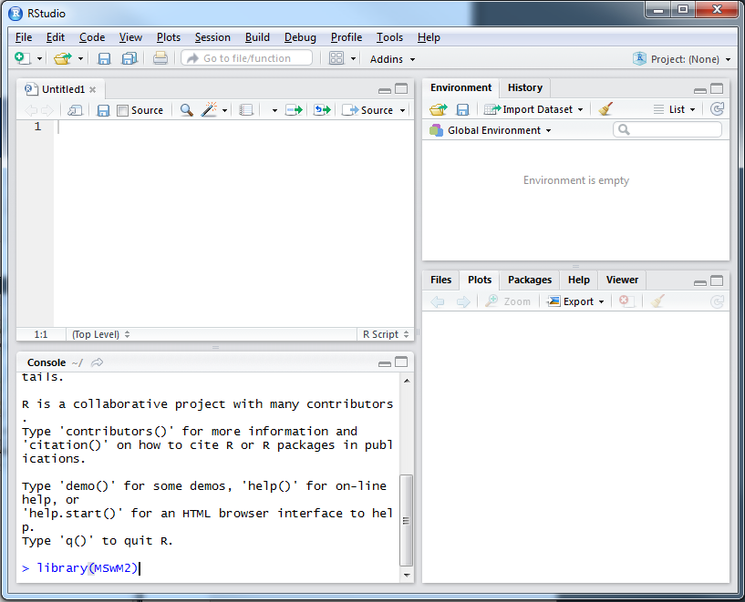

Type library(MSwM2) in the R Console. It is the command to load package into R.